Practical No: 02

**Aim:** Displaying Time over 16x2 LCD Display using Raspberry Pi.

**Hardware Required:**

1. Raspberry Pi 3B+
2. Ethernet Cable
3. Monitor
4. HDMI to VGI convertor
5. Micro SD card (any class best is class 10)
6. Adaptor with 5v 2A
7. USB mouse
8. USB keyboard
9. jumper wires
10. 16x2 LCD Display
11. Breadboard

**Software Required:**

1. Rapbeian OS
2. Thonny Python IDE

**Procedure:**

1. **Hardware Setup:**

* Connect the pins as given bellow….
* LCD **Pin 1** to **GND** ofPi
* LCD **Pin 2** to **VCC 5+** ofPi
* LCD **Pin 3** to **Middle Pin** of Potentiometer
* LCD **Pin 4** to **GPIO22** ofPi
* LCD **Pin 5** to **GND** ofPi
* LCD **Pin 6** to **GPIO17** ofPi
* LCD **Pin 11** to **GPIO25** ofPi
* LCD **Pin 12** to **GPIO24** ofPi
* LCD **Pin 13** to **GPIO23** ofPi
* LCD **Pin 14** to **GPIO18** ofPi
* LCD **Pin 15** to **VCC 5+** ofPi
* LCD **Pin 16** to **GND** of Pi
* Potentiometer **one Pin** to **GND**
* Potentiometer **other Pin** to **VCC 5+**

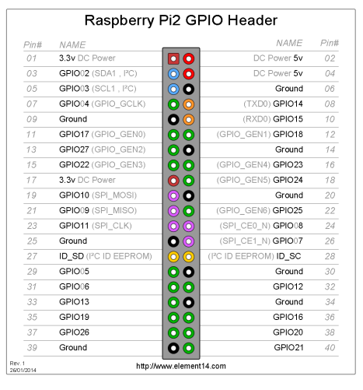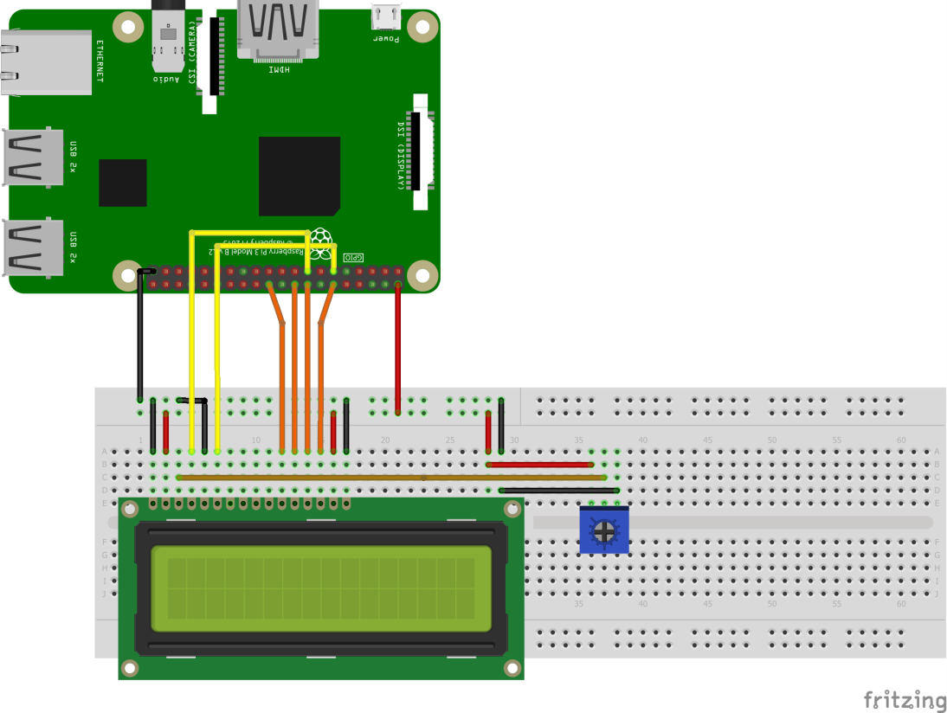

1. **Software Setup:**

* Change Time zone to match India: Start 🡺 Preferences 🡺 Raspberry Pi Configuration 🡺 Localization 🡺 Set Timezone 🡺 Area: Asia, Location: Kolkata.
* Type the following commands in the terminal…
* *pip3 install adafruit-circuitpython-charlcd*
* Open Thonny Python IDE and type the following code in the editor…

*from time import sleep*

*from datetime import datetime*

*import board*

*import digitalio*

*import adafruit_character_lcd.character_lcd as characterlcd*

*lcd_columns = 16*

*lcd_rows = 2*

*lcd_rs = digitalio.DigitalInOut(board.D22)*

*lcd_en = digitalio.DigitalInOut(board.D17)*

*lcd_d4 = digitalio.DigitalInOut(board.D25)*

*lcd_d5 = digitalio.DigitalInOut(board.D24)*

*lcd_d6 = digitalio.DigitalInOut(board.D23)*

*lcd_d7 = digitalio.DigitalInOut(board.D18)*

*lcd = characterlcd.Character_LCD_Mono(lcd_rs, lcd_en, lcd_d4, lcd_d5, lcd_d6,lcd_d7, lcd_columns, lcd_rows)*

*while True:*

*fixed=datetime.now()*

*lcd_line_1 = fixed.strftime('%a %d %b %Y\n')*

*lcd_line_2=fixed.strftime(" %I:%M:%S %p")*

*lcd.message = lcd_line_1+lcd_line_2*

*print(lcd_line_1+lcd_line_2)*

**Precautions:**

* If it is a fresh flash of Raspbian OS “*sudo apt update”* and “*sudo apt upgrade”* is a must thing.
* 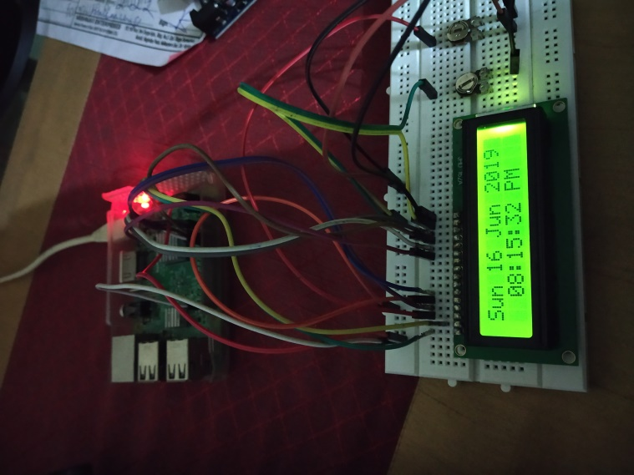Connect the components before powering on the device and double check your connections.